**SWEN – 5232 SOFTWARE CONSTRUCTION**

**Attendance using smart card**

**Submitted by**

**Sri Himaja Korrapati**

**1810548**

**Gayatri Devi Jetti**

**1828070**

**Suram Rikith Kumar Reddy**

**1813662**

**Table of Content**

1. Brainstorming .………………………………………………………………………………………………………………………3
2. Use case Diagrams ..……………………………………………………………………………………………………………….4

2.1 Login use case ..………………………………………………………………………………………………………………..4

2.2 Faculty Login ..………………………………………………………………………………………………………………….6

2.3 Different login user’s ..……………………………………………………………………………………………………..8

2.4 Overriding attendance use case ……………………………………………………………………………………..10

2.5 Student checkin use-case ……………………………………………………………………………………………….11

2.6Student’s Attendance view use case ………………………………………………………………………………. 12

1. Domain Modeling ………………………………………………………………………………………………………………..14

3.1 Cloud Level …………………………………………………………………………………………………………………….14

3.2 Kite Level ……………………………………………………………………………………………………………………….15

1. Activity Diagrams …………………………………………………………………………………………………………………16

4.1 Basic Flow ……………………………………… …….……………………………………………………………………….16

4.2 Alternative Flow …………………………………………………………………………………………………………….17

4.3 Parallel Flow ……………………………………………………………………………………………………………………17

1. State Machine Diagrams ……………………………………………………………………………………………………… 19

5.1 Admin .…….………………………………………………….………………………………………………………………….19

5.2 Student .……………………………………………………...………………………………………………………………….20

1. Layer Diagrams …………………………………………………………………………………………………………………….21
2. Component Diagrams …………………………………………………………………………………………………………..22
3. Sequence Diagrams ………………………………………………………………………………………………………………23

8.1 Login …………………………………………….………………………………………………………………………………..23

8.2 Faculty ………………………………………….………………………………………………………………………………..24

8.3 Override .………………………………………………………………………………………………………………………..25

8.4 Student …………….…………………………………………………………………………………………………………..26

8.5 Attendance History ……………..…………………………………………………………………………………………27

1. Class Diagrams ……………………………………………………………………………………………………………………..28

9.1 Basic Flow ………………………………………………………………………………………………………………………28

* 1. Alternative Flow ……………………………………………………………………………………………………………29

1. **Brainstorming**

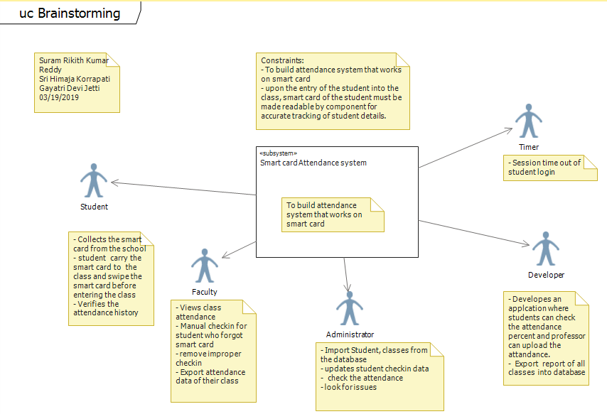

1. **Use case diagrams**

**Revision Box**

|  |  |  |  |
| --- | --- | --- | --- |
| Name | Date | Reason for Changes | Version |
| Gayatri Devi Jetti | 3/19/2019 | Initialize | 1.0 |
| Sri Himaja Korrapati | 3/20/2019 | Update | 1.1 |
| Suram Rikith Kumar Reddy | 3/22/2019 | Finalize | 1.1 |

Use Case scenario 2.1

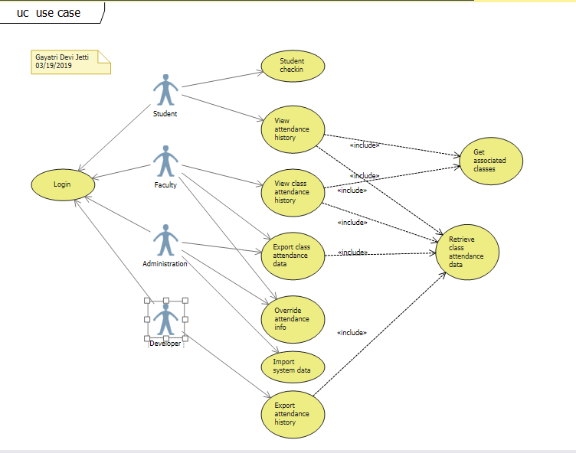

|  |  |
| --- | --- |
| Name: | View of smart card |
| Created By: | Gayatri Devi Jetti  Sri Himaja Korrapati  Suram Rikith Kumar Reddy |
| Date Created: | 03/19/2019 |
| Updated By: | Suram Rikith Kumar Reddy  Sri Himaja Korrapati |
| Date Last Updated: | 03/22/2019 |
| System/Subsystem: | Login |
| Brief Description: | Login and can check the data |
| Basic Flow: | * Login as student * Student need to login to check the attendance percentage. * Student can view attendance history in the associated class. * Student can retrieve the attendance data. * Login as faculty * Faculty can view class attendance history. * Faculty can export the attendance the data. * Login as Admin * Admin exports class attendance data. * Imports system data. * Login as Developer * Exports the attendance history * Retrieve the class attendance data |
| Alternative Flow: | None |
| Special Requirements: | Student, faculty, admin need to login |
| Pre-Conditions: | Developer and admin need to import the data |
| Post Conditions: | All can view the page after login |
| Extension Points: | None |

Use case scenario 2.2

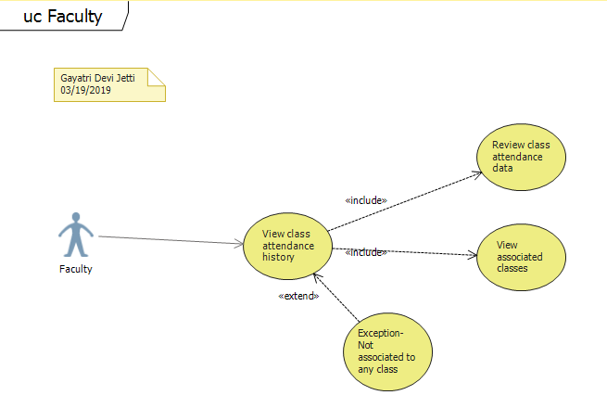

|  |  |
| --- | --- |
| Name: | Faculty view of class |
| Created By: | Gayatri Devi Jetti  Sri Himaja Korrapati  Suram Rikith Kumar Reddy |
| Date Created: | 03/19/2019 |
| Updated By: | Suram Rikith Kumar Reddy  Sri Himaja Korrapati |
| Date Last Updated: | 03/22/2019 |
| System/Subsystem: | Faculty |
| Brief Description: | Faculty can upload and view the attendance |
| Basic Flow: | * Faculty need to upload the attendance * Faculty can view the class attendance history. * After looking on to the class attendance history, faculty can review the class attendance data. |
| Alternative Flow: | None |
| Special Requirements: | Faculty need to login and upload the attendance. |
| Pre-Conditions: | Faculty need to login. |
| Post Conditions: | All can view the data. |
| Extension Points: | None |

Use case scenario 2.3

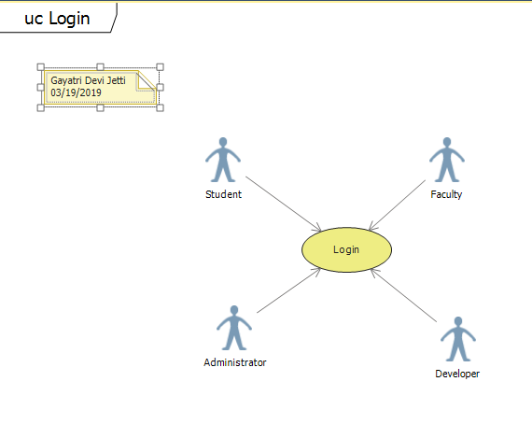

|  |  |
| --- | --- |
| Name: | Different kinds of user login |
| Created By: | Gayatri Devi Jetti  Sri Himaja Korrapati  Suram Rikith Kumar Reddy |
| Date Created: | 03/19/2019 |
| Updated By: | Suram Rikith Kumar Reddy  Sri Himaja Korrapati |
| Date Last Updated: | 03/22/2019 |
| System/Subsystem: | Login |
| Brief Description: | All can login and modify the data |
| Basic Flow: | * Student can login and view the attendance percentage. * Faculty can login, upload the data and view attendance history. * Admin can login and export class attendance data and imports system data. * Developer can login and retrieve the calls attendance data. |
| Alternative Flow: | None |
| Special Requirements: | None |
| Pre-Conditions: | Developer and admin need to import the data |
| Post Conditions: | All can view the page after login |
| Extension Points: | None |

Use case scenario 2.4

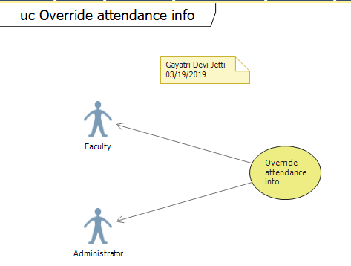

|  |  |
| --- | --- |
| Name: | Override attendance information |
| Created By: | Gayatri Devi Jetti  Sri Himaja Korrapati  Suram Rikith Kumar Reddy |
| Date Created: | 03/19/2019 |
| Updated By: | Suram Rikith Kumar Reddy  Sri Himaja Korrapati |
| Date Last Updated: | 03/22/2019 |
| System/Subsystem: | Attendance |
| Brief Description: | Overriding the attendance data |
| Basic Flow: | * Student attendance data and history might override. |
| Alternative Flow: | None |
| Special Requirements: | Developer need to take care of override. |
| Pre-Conditions: | Data need to be uploaded carefully. |
| Post Conditions: | Override doesn’t take place. |
| Extension Points: | None |

Use case scenario 2.5

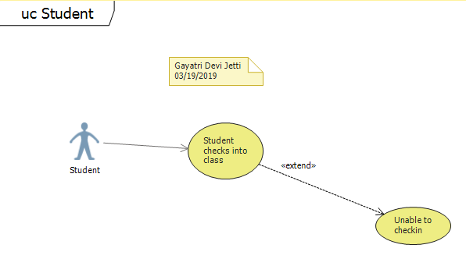

|  |  |
| --- | --- |
| Name: | Usage of smart card |
| Created By: | Gayatri Devi Jetti  Sri Himaja Korrapati  Suram Rikith Kumar Reddy |
| Date Created: | 03/19/2019 |
| Updated By: | Suram Rikith Kumar Reddy  Sri Himaja Korrapati |
| Date Last Updated: | 03/22/2019 |
| System/Subsystem: | Check in |
| Brief Description: | Student check in |
| Basic Flow: | * Student checkin to the class using smart card |
| Alternative Flow: | If the student is unable to checkin contact faculty or admin |
| Special Requirements: | None |
| Pre-Conditions: | Student need to swipe the smart card |
| Post Conditions: | Student can enter into the class |
| Extension Points: | None |

Use case scenario 2.6

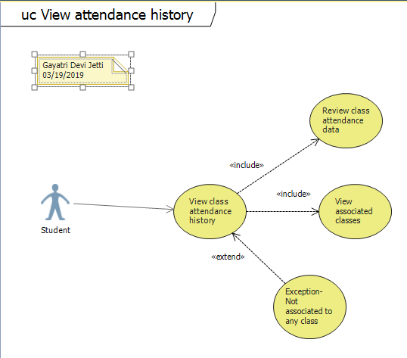

|  |  |
| --- | --- |
| Name: | View class attendance history |
| Created By: | Gayatri Devi Jetti  Sri Himaja Korrapati  Suram Rikith Kumar Reddy |
| Date Created: | 03/19/2019 |
| Updated By: | Suram Rikith Kumar Reddy  Sri Himaja Korrapati |
| Date Last Updated: | 03/22/2019 |
| System/Subsystem: | Login |
| Brief Description: | Students can check attendance data |
| Basic Flow: | * Students can check class attendance history * After checking the data, they can review the attendance data. |
| Alternative Flow: | None |
| Special Requirements: | Student need to check the data. |
| Pre-Conditions: | Student need to login to check the attendance data. |
| Post Conditions: | Student can review the class attendance history. |
| Extension Points: | None |

1. **Domain Modelling:**

3.1) Cloud level:

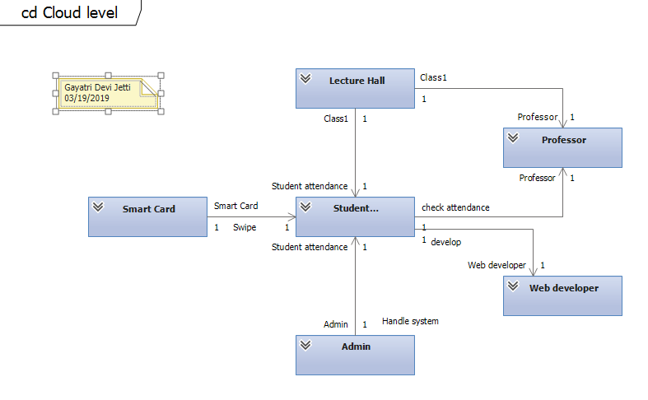

3.2) Kite Level:

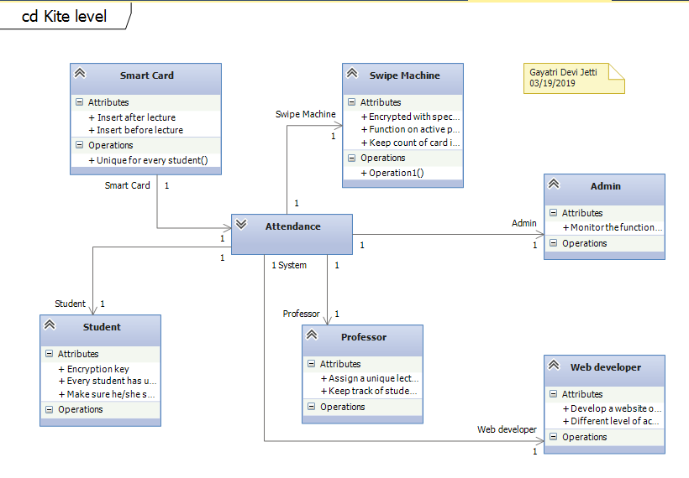

1. **Activity diagram:**

4.1)

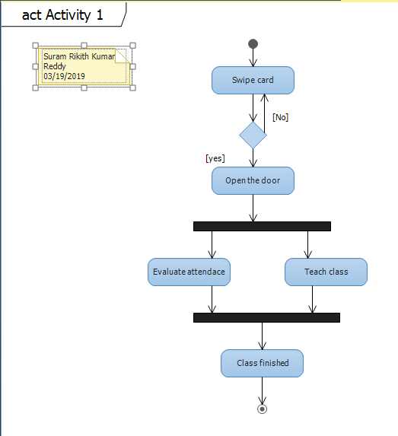

4.2)

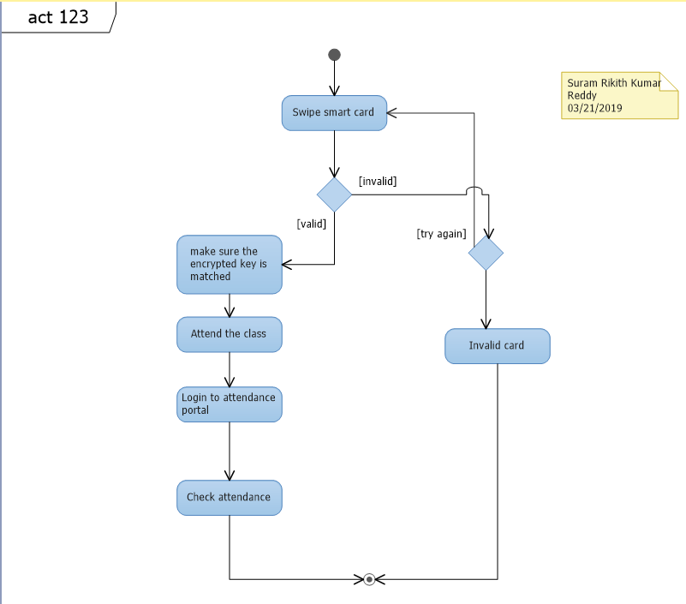

4.3)

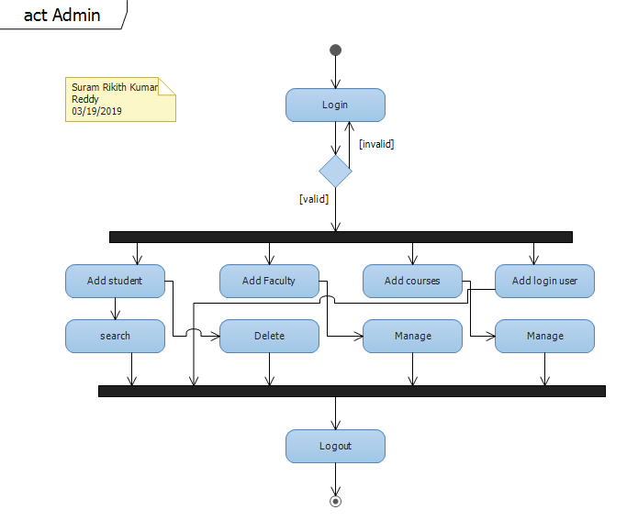

1. **State Machine Diagrams:**

5.1)

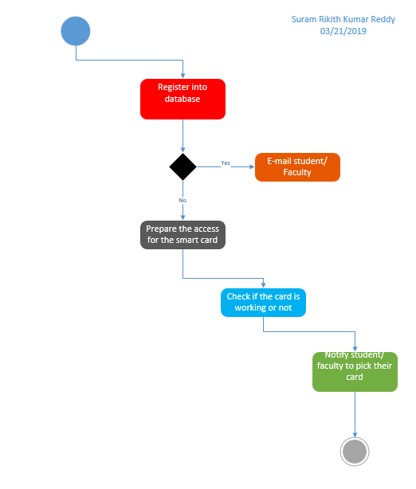

5.2)

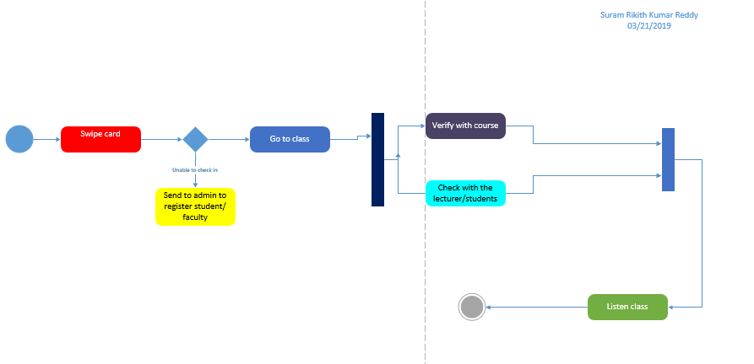

**6)** **Layer Diagram:**

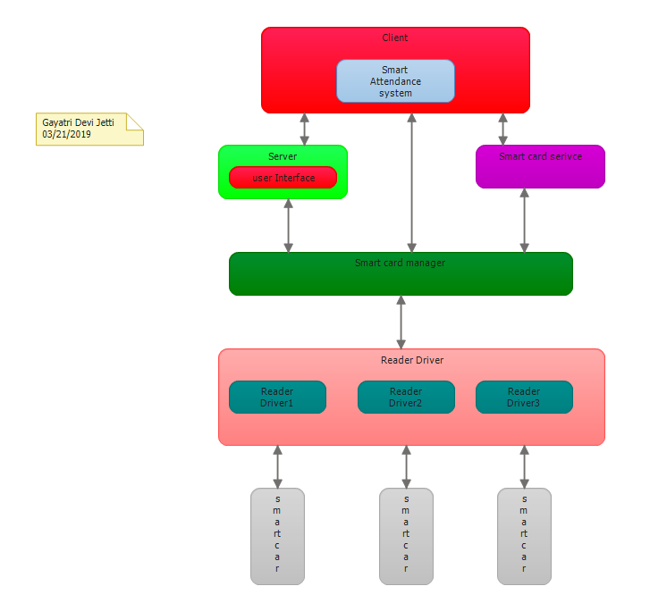

**7) Component Diagram**

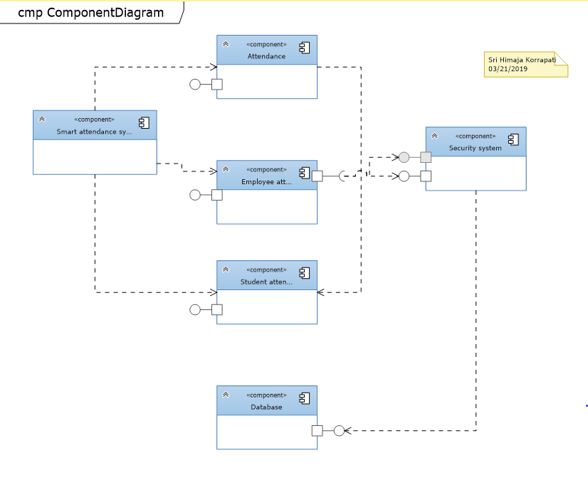

**8) Sequence Diagrams:**

8.1)

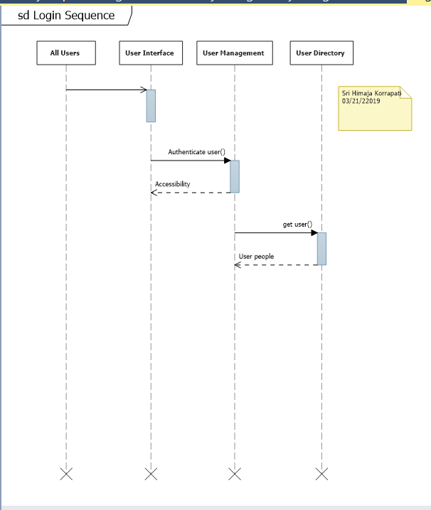

8.2)

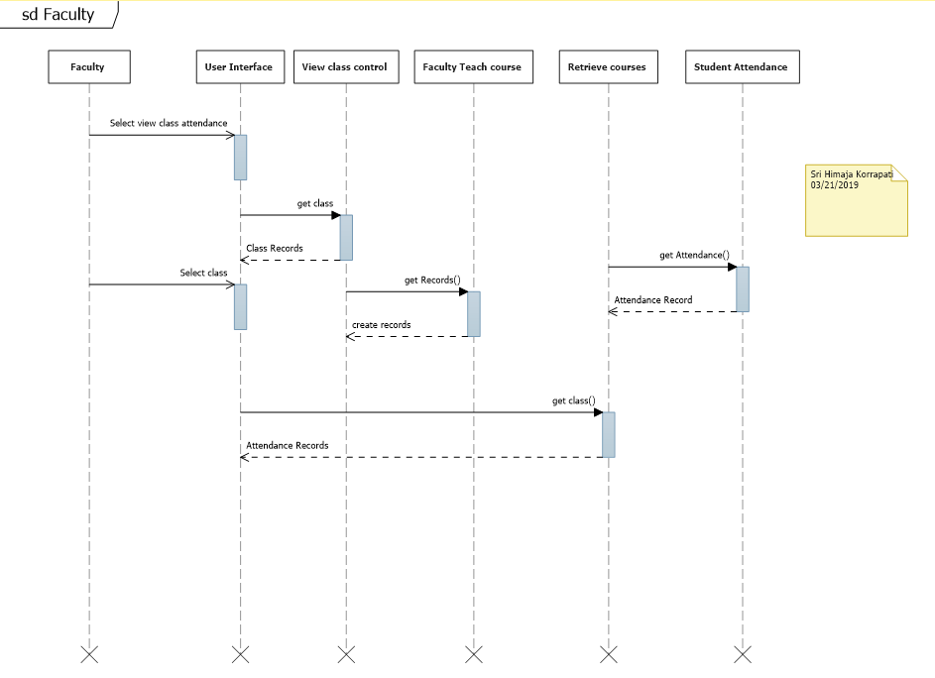

8.3)

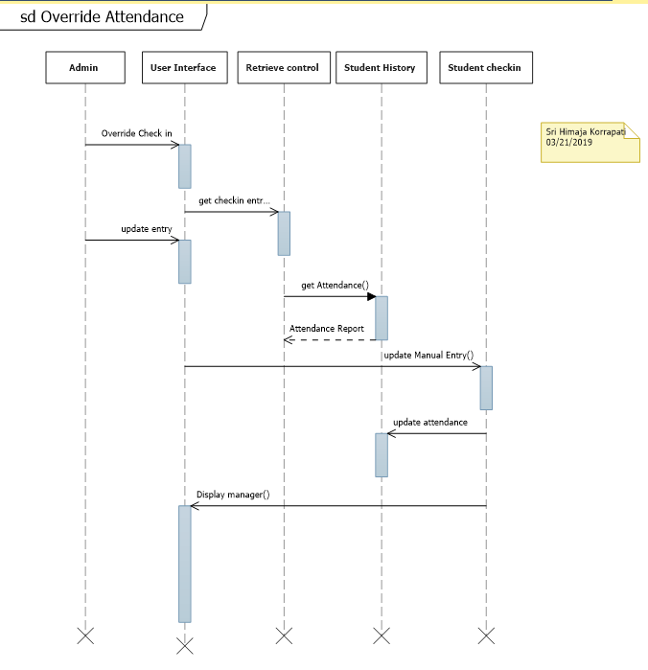

8.4)

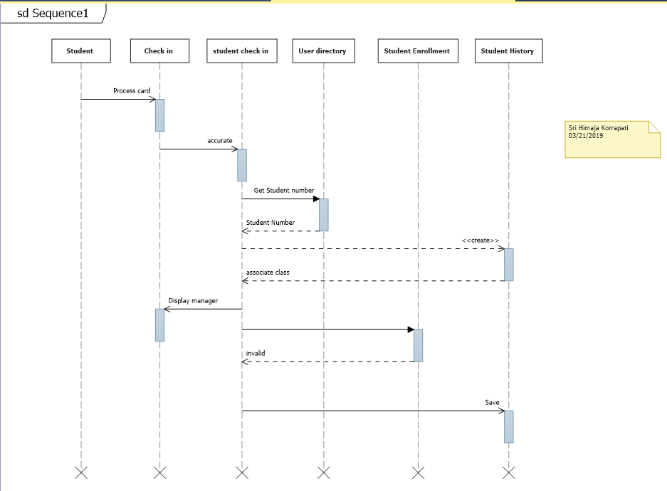

8.5)

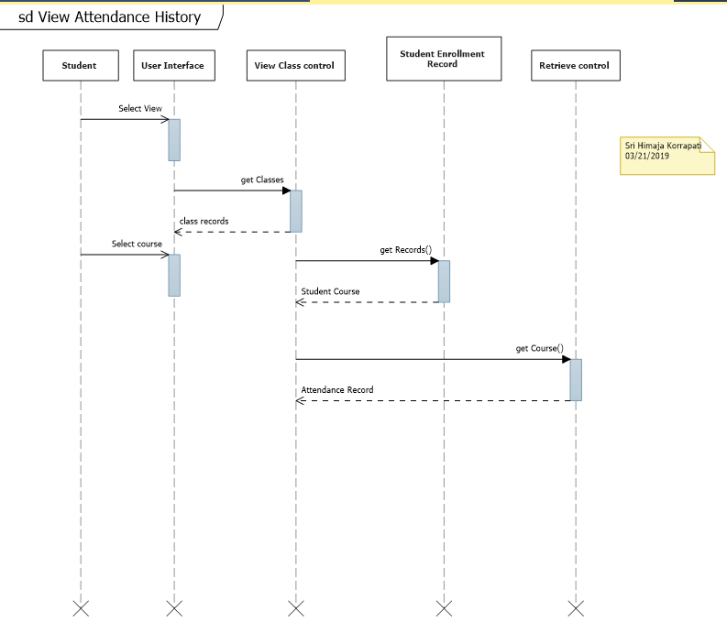

**9) Class Diagrams:**

9.1)

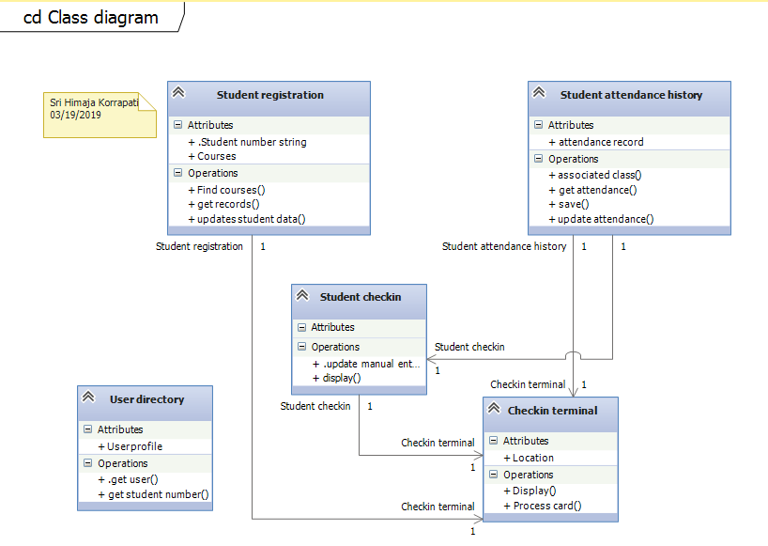

9.2)

